Our Ref: 2018/2934/CORR/005

Date: 17 January 2018

Notice

Re: Vandalism at BLK 8

Dear Residents of BLK 8,

This is to inform that circulars to the notice board in the lift if not found can be obtained from the Web portal. Circulars which was placed recently were torn off and thrown away.

The notice board in the lift PL3 has been damaged even though it was repaired for a few times since it was placed.

The guards were informed to be look out for the culprit involved.
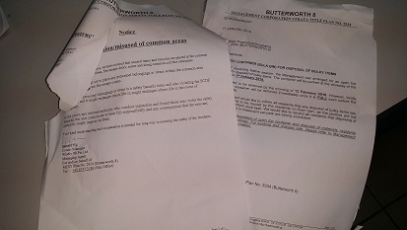
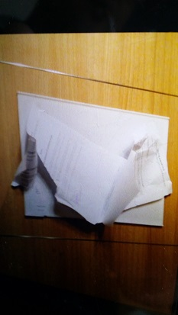
Your co operation to keep an eye of those suspicious personnel is required and report immediately to the guards.

Renald Ng
Condo Manager
Wisely 98 Pte Ltd
Managing Agent
For and on behalf of
MCST Plan No. 2934 (Butterworth 8)
Tel : +65 6747 3184 (Site Office)

